ORX — Veeam Backup for Microsoft 365
Monthly Backup Report — 2026-03
M365 tenant: ORX365.onmicrosoft.com
Report generated: 2026-05-02 18:21
Executive Summary
467 M365 users in this tenant are protected by Veeam Backup for Microsoft 365. Total backup storage in use is 4.10 TB across 2 repositories, with 1 active backup job. This report breaks down storage by Microsoft 365 service, lists per-user backup coverage, and projects how storage will grow over the next 12 months.
467  M365 Users | 147  Users w/ OneDrive backed up | 4.10 TB  Backup Storage Used | 1  Backup Jobs (Running)
Backup Posture
Job | Backup Type | Last Run | Status | Enabled | Next Run
ORX-365 | EntireOrganization | - | Running | Yes | 2026-05-02T20:10:00Z
Backup repositories:
Repository | Used | Capacity | Free | Path
ORX-O365 | 3.82 TB | 99.37 GB | 31.78 GB | C:\O365 Backups\bkp_ORX-365
ORX_365_New | 284.28 GB | 5.00 TB | 4.72 TB | C:\O365 Backups\bkp_ORX365

Storage by M365 Module
Per-module bytes are estimated by attributing the tenant's total used backup storage in proportion to how often each service appeared in restore points over the last 90 days, weighted by industry-default ratios. For exact per-mailbox / per-site sizes, run the VB365 PowerShell module (Get-VBOEntityData).
Module | Estimated Storage | Share of Total | RP coverage (last 90d)
Exchange | 1.06 TB | 25.9% | 695 / 2,644
OneDrive | 1.84 TB | 44.9% | 2,643 / 2,644
SharePoint | 1.10 TB | 26.9% | 2,644 / 2,644
Teams | 96.17 GB | 2.3% | 675 / 2,644
Per-User Backup Coverage
467 users in the M365 directory. Mailbox coverage is set Yes for every user when the job is EntireOrganization (current setting). OneDrive coverage is determined by probing /users/{id}/onedrives.
Display Name | Email | Mailbox | OneDrive
Dave White | DWhite@orthoxpress.com | Yes | Yes
Catherine Locquiao | clocquiao@orthoxpress.com | Yes | No
Christopher Mendez | ctmendez@orthoxpress.com | Yes | No
Soft Man | admin@ORX365.onmicrosoft.com | Yes | Yes
Clerie Staten | cstaten@orthoxpress.com | Yes | Yes
Bianca Navarro | bnavarro@orthoxpress.com | Yes | Yes
billing | billing@orthoxpress.com | Yes | No
authorizations | authorizations@orthoxpress.com | Yes | No
Delores Freeman | dfreeman@orthoxpress.com | Yes | No
Dawn Bowe | DBowe@orthoxpress.com | Yes | Yes
alliance ortho | aortho@orthoxpress.com | Yes | No
Ava Perez | aperez@ORX365.onmicrosoft.com | Yes | No
Chris Benson | CBenson@ORX365.onmicrosoft.com | Yes | No
Compliance | Compliance@orthoxpress.com | Yes | No
Angela Green | AGreen@ORX365.onmicrosoft.com | Yes | No
Ana Martinez | amartinez@orthoxpress.com | Yes | Yes
Desirae Barrios | dbarrios@orthoxpress.com | Yes | Yes
Crystal Grode | CGrode@ORX365.onmicrosoft.com | Yes | No
cancellations | cancellations@orthoxpress.com | Yes | No
adp | adp@orthoxpress.com | Yes | No
Deepak Tomer | DTomer@ORX365.onmicrosoft.com | Yes | No
DFallera | DFallera@ORX365.onmicrosoft.com | Yes | No
Daisy Sanchez | dsanchez@orthoxpress.com | Yes | Yes
Chad Schoenthal | CSchoenthal@ORX365.onmicrosoft.com | Yes | No
Donna Cable | DCable@orthoxpress.com | Yes | No
Brittany Morales | BMorales@orthoxpress.com | Yes | Yes
Deborah Ayala | dayala@orthoxpress.com | Yes | Yes
Brendan Udolph | BUdolph@orthoxpress.com | Yes | Yes
collections | collections@orthoxpress.com | Yes | No
Daniel Gonzales | DGonzales@orthoxpress.com | Yes | No
DMARC Aggr Reports | demarcaggrreports@orthoxpress.com | Yes | No
Dayton Nguyen | dnguyen@orthoxpress.com | Yes | Yes
Charlene Walker | cwalker@orthoxpress.com | Yes | Yes
Brett Varner | BVarner@orthoxpress.com | Yes | Yes
Dylan Zyber | dzyber@orthoxpress.com | Yes | Yes
Dinora Castellanos | DCastellanos@orthoxpress.com | Yes | No
Booking | Booking@falconerofredlands.com | Yes | No
Christopher Thurman | cthurman@orthoxpress.com | Yes | Yes
Diana Resendiz | dresendiz@orthoxpress.com | Yes | No
Chase Szabo | cszabo@orthoxpress.com | Yes | Yes
MailStore Archive SA | Archive-SA@ORX365.onmicrosoft.com | Yes | No
Cody Laderman | claderman@orthoxpress.com | Yes | Yes
Cameron Simons | csimons@orthoxpress.com | Yes | Yes
Azure AD | azuread@orthoxpress.com | Yes | No
Derek Mendez | dmendez@orthoxpress.com | Yes | Yes
Brandi Brushett | BBrushett@orthoxpress.com | Yes | No
Daniel Tieman | dtieman@orthoxpress.com | Yes | No
Ashley Veasy | aveasy@orthoxpress.com | Yes | Yes
Christie Hall | Chall@orthoxpress.com | Yes | Yes
Charon Shorty | CShorty@orthoxpress.com | Yes | Yes
… and 417 additional users (full list in data.json).

Storage Trend & Projection
Projection method: industry default 4% MoM (will refine after 2+ monthly snapshots). Compound monthly growth rate used: 4.00%.
Horizon | Projected Storage | Δ vs today
Today (snapshot) | 4.10 TB | —
+3 months | 4.61 TB | +524.20 GB
+6 months | 5.19 TB | +1.09 TB
+9 months | 5.84 TB | +1.74 TB
+12 months | 6.56 TB | +2.46 TB
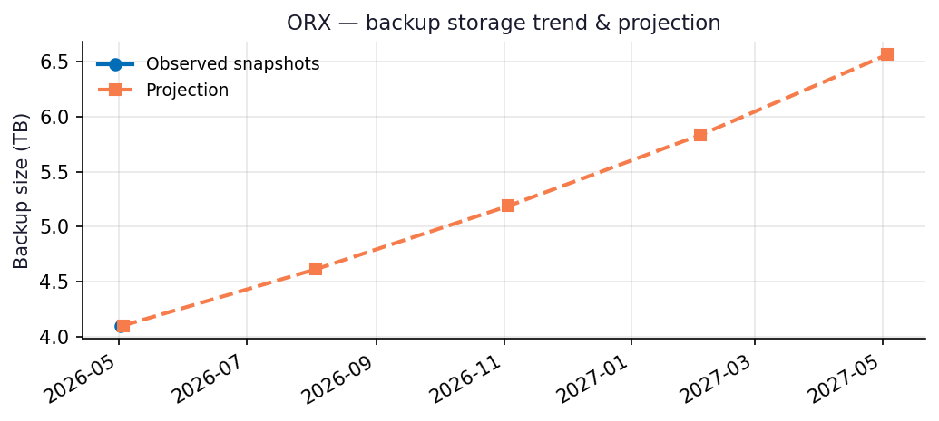
Recommendations
- Repository ORX-O365 is 68% full (31.78 GB free of 99.37 GB capacity).
- Capacity flag: Repository will hit ~90% utilization within 3 months at the current trend — begin capacity planning now.
- Coverage gap: Only 147/467 users have OneDrive backups. Confirm whether the remainder are intentionally excluded (licensing, role-based scope) or need to be added.
- Run this report monthly. The projection accuracy improves with each snapshot — after 3 snapshots the linear-regression fit replaces the industry-default growth assumption.

Appendix: Methodology & Data Sources
Data sources
- Veeam Backup for Microsoft 365 REST API at https://10.7.9.227:4443/v8 (OAuth2 password grant; self-signed TLS).
- Endpoints used: /Organizations, /Organizations/{id}/usedRepositories, /Organizations/{id}/users, /Organizations/{id}/users/{uid}/onedrives, /BackupRepositories, /Jobs, /RestorePoints?backupTimeFrom=...
Per-module attribution caveat
REST does not expose per-mailbox or per-OneDrive backup byte counts on this build. Per-module estimates reweight the total used storage by the share of restore points (over the trailing 90 days) that included each service. Treat the numbers as informed estimates, not invoiced figures. For ground-truth per-user/per-team sizes use the VB365 PowerShell module Get-VBOEntityData.
Trend projection
- With <2 monthly snapshots: project at 4%/month compound.
- With ≥2 snapshots: linear regression on log(bytes) over time.

